**Assignment No 5**

**Shivam Navnath Giri**

**CDAC PGDAI SILCHAR**

**FOI**

**Q1. Explore the search space diagram for the tic-tac toe game .Solve using minmax algorithm to find the optimal path where the max would win.**

**Assumption: Selection of appropriate value of utility numbers and begin with**

**the max player**



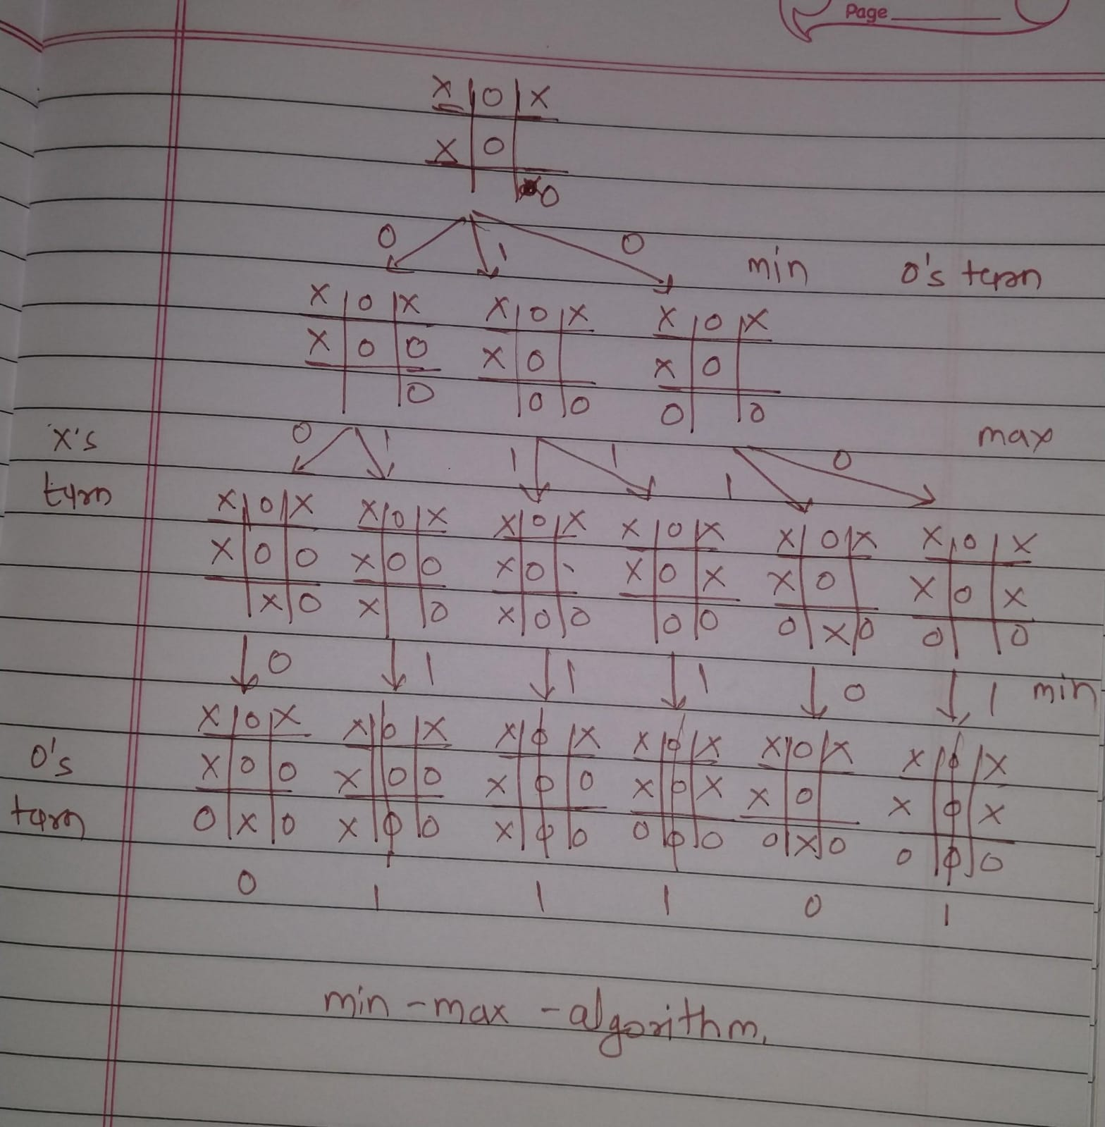

**Q2. Each letter is one digit integer 0,1,2 to 9, each having a different value.**

**What are the values of each of the letters? Solve to make your agent rationally**

**think in terms of domains and variables as well.**

**SEND**

**+**

**MORE**

**------------**

**MONEY**

**Solution :**

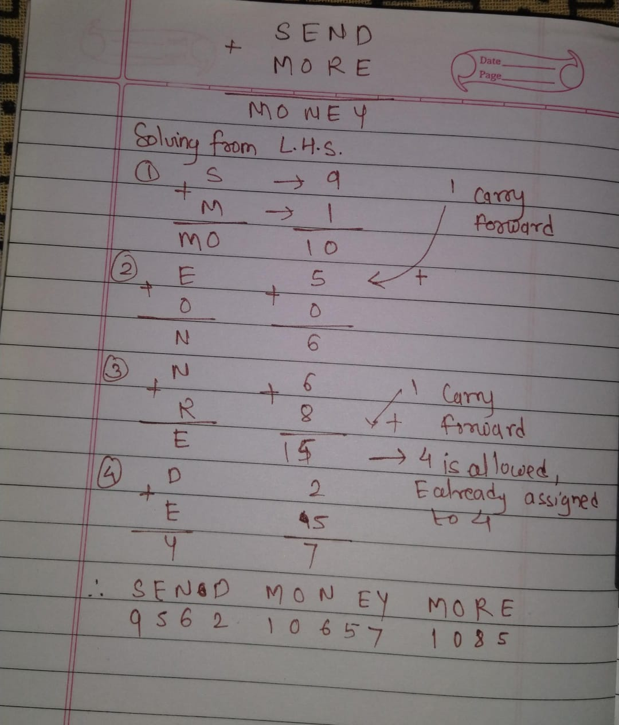

**Q3 . Solve the game tree using alpha-beta pruning algorithm. Evaluate the**

**respective utility number at the root of the game tree.**

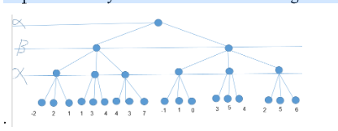

**Solution :**

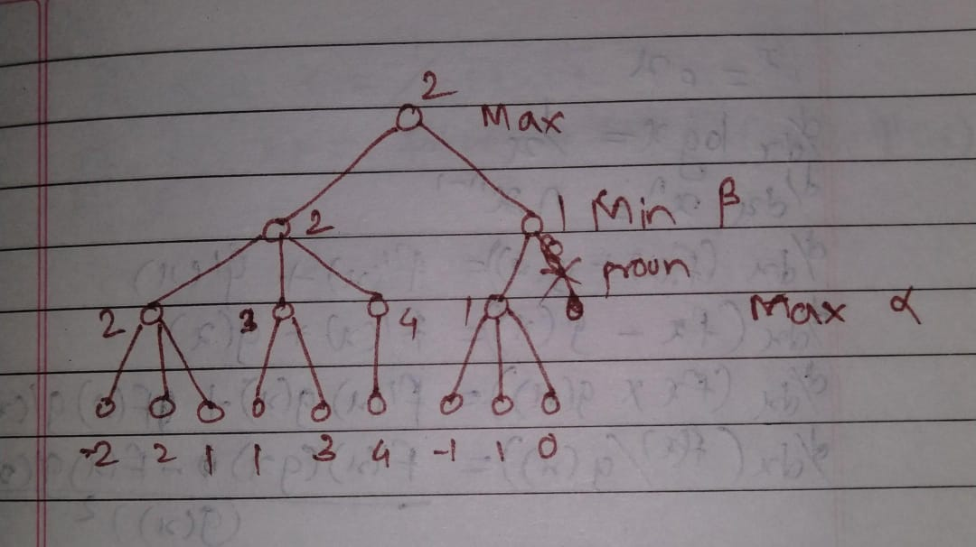

**Q4. Given an undirected graph and a number m, determine if the graph can be**

**coloured with at most 3colours such that no two adjacent vertices of the graph**

**are colored with the same color. Here coloring of a graph means the assignment**

**of colors to all vertices. (use backtrack)**

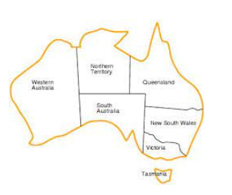

**Solution:**

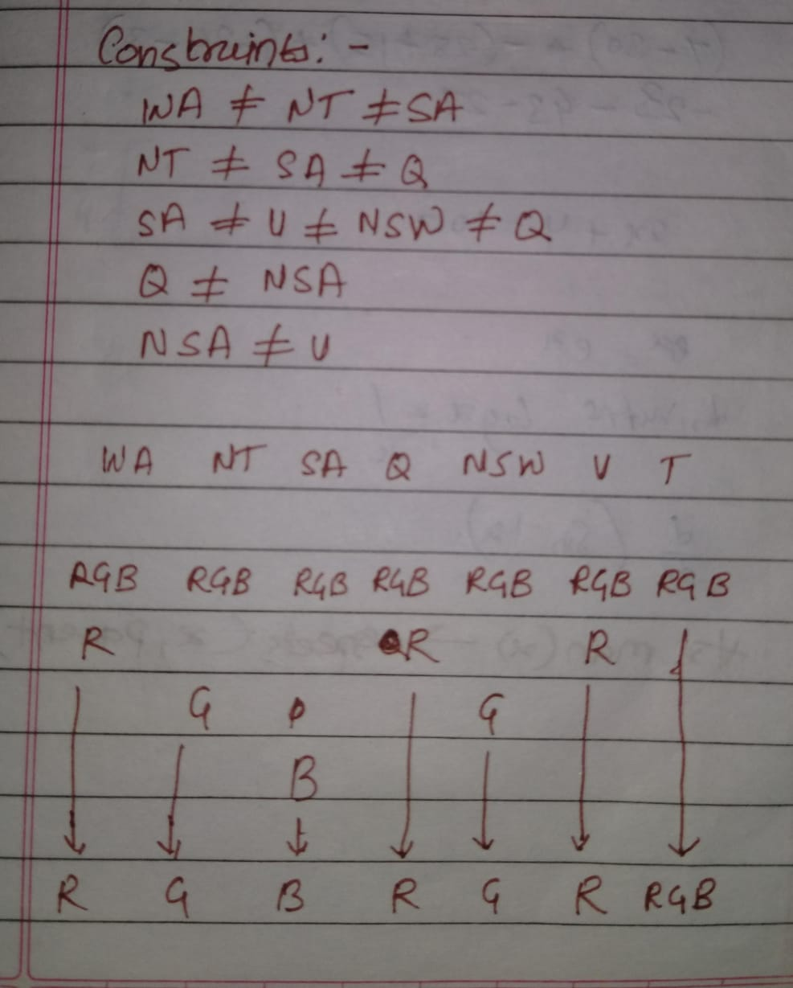

**Q5. Solve the N-Queens problem using Genetic Algorithm.**

**Solution :**